**ArrayList in java with example programs – Collections Framework**

By Chaitanya Singh | Filed Under: [Java Collections](https://beginnersbook.com/category/java-collections/)

**Arraylist** class implements List interface and it is based on an Array data structure. It is widely used because of the functionality and flexibility it offers. Most of the developers **choose Arraylist over Array** as it’s a very good alternative of traditional java arrays. ArrayList is a resizable-array implementation of the List interface. It implements all optional list operations, and permits all elements, including null.

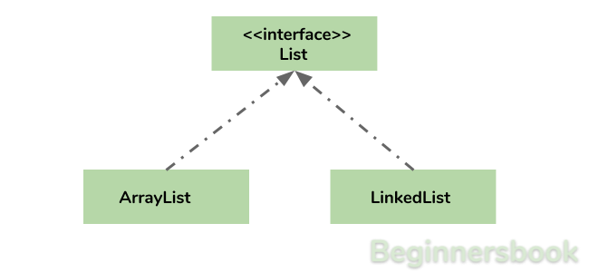

**Why ArrayList is better than Array?**

The limitation with array is that it has a fixed length so if it is full you cannot add any more elements to it, likewise if there are number of elements gets removed from it the memory consumption would be the same as it doesn’t shrink.

On the other ArrayList can dynamically grow and shrink after addition and removal of elements (See the images below). Apart from these benefits ArrayList class enables us to use predefined methods of it which makes our task easy. Let’s see the diagrams to understand the addition and removal of elements from ArrayList and then we will see the programs.

**Adding Element in ArrayList at specified position:**  
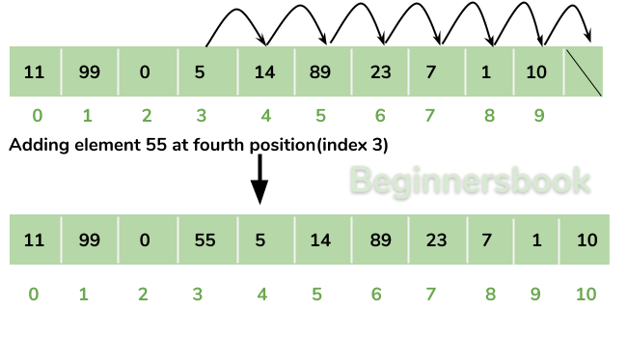

**Removing Element from ArrayList:**  
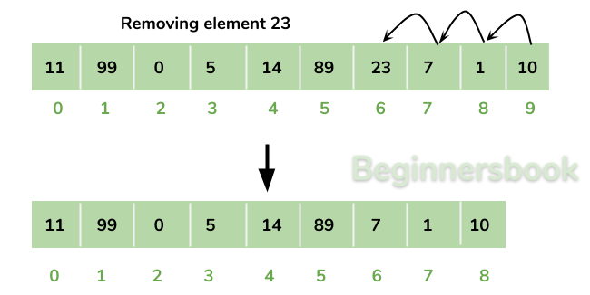

There is a list of several tutorials on ArrayList at the end of this guide, refer it to understand and learn ArrayList concept fully.

**How to create an ArrayList?**

We can create an ArrayList by writing a simple statement like this:

This statement creates an ArrayList with the name alist with type “String”. The type determines which type of elements the list will have. Since this list is of “String” type, the elements that are going to be added to this list will be of type “String”.

ArrayList<String> alist=new ArrayList<String>();

Similarly we can create ArrayList that accepts int elements.

ArrayList<Integer> list=new ArrayList<Integer>();

**How to add elements to an ArrayList?**

We add elements to an ArrayList by using add() method, this method has couple of variations, which we can use based on the requirement. For example: If we want to add the element at the end of the List then simply do it like this:

alist.add("Steve"); //This will add "Steve" at the end of List

To add the element at the specified location in ArrayList, we can specify the index in the add method like this:

alist.add(3, "Steve"); //This will add "Steve" at the fourth position

Lets write the complete code:

import java.util.*;

class JavaExample{

public static void main(String args[]){

ArrayList<String> alist=new ArrayList<String>();

alist.add("Steve");

alist.add("Tim");

alist.add("Lucy");

alist.add("Pat");

alist.add("Angela");

alist.add("Tom");

//displaying elements

System.out.println(alist);

//Adding "Steve" at the fourth position

alist.add(3, "Steve");

//displaying elements

System.out.println(alist);

}

}

**Output:**

[Steve, Tim, Lucy, Pat, Angela, Tom]

[Steve, Tim, Lucy, Steve, Pat, Angela, Tom]

**Note:** Since the index starts with 0, index 3 would represent fourth position not 3.

**How to remove elements from ArrayList?**

We use remove() method to remove elements from an ArrayList, Same as add() method, this method also has few variations.

For example:

import java.util.*;

class JavaExample{

public static void main(String args[]){

ArrayList<String> alist=new ArrayList<String>();

alist.add("Steve");

alist.add("Tim");

alist.add("Lucy");

alist.add("Pat");

alist.add("Angela");

alist.add("Tom");

//displaying elements

System.out.println(alist);

//Removing "Steve" and "Angela"

alist.remove("Steve");

alist.remove("Angela");

//displaying elements

System.out.println(alist);

//Removing 3rd element

alist.remove(2);

//displaying elements

System.out.println(alist);

}

}

**Output:**

[Steve, Tim, Lucy, Pat, Angela, Tom]

[Tim, Lucy, Pat, Tom]

[Tim, Lucy, Tom]

**Iterating ArrayList**

In the above examples, we have displayed the ArrayList elements just by referring the ArrayList instance, which is definitely not the right way to displays the elements. The correct way of displaying the elements is by using an advanced for loop like this.

import java.util.*;

class JavaExample{

public static void main(String args[]){

ArrayList<String> alist=new ArrayList<String>();

alist.add("Gregor Clegane");

alist.add("Khal Drogo");

alist.add("Cersei Lannister");

alist.add("Sandor Clegane");

alist.add("Tyrion Lannister");

//iterating ArrayList

for(String str:alist)

System.out.println(str);

}

}

**Output:**

Gregor Clegane

Khal Drogo

Cersei Lannister

Sandor Clegane

Tyrion Lannister

**ArrayList Example in Java**

This example demonstrates how to create, initialize, add and remove elements from ArrayList. In this example we have an ArrayList of type “String”. We have added 5 String element in the ArrayList using the method add(String E), this method adds the element at the end of the ArrayList.

We are then adding two more elements in the ArrayList using method add(int index, String E), this method adds the specified element at the specified index, index 0 indicates first position and 1 indicates second position.

We are then removing the elements “Chaitanya” and “Harry” from the ArrayList and then we are removing the second element of the ArrayList using method remove(int index). Since we have specified the index as 1 (remove(1)), it would remove the second element.

import java.util.*;

public class JavaExample {

public static void main(String args[]) {

/* Creating ArrayList of type "String" which means

* we can only add "String" elements

*/

ArrayList<String> obj = new ArrayList<String>();

/*This is how we add elements to an ArrayList*/

obj.add("Ajeet");

obj.add("Harry");

obj.add("Chaitanya");

obj.add("Steve");

obj.add("Anuj");

// Displaying elements

System.out.println("Original ArrayList:");

for(String str:obj)

System.out.println(str);

/* Add element at the given index

* obj.add(0, "Rahul") - Adding element "Rahul" at first position

* obj.add(1, "Justin") - Adding element "Justin" at second position

*/

obj.add(0, "Rahul");

obj.add(1, "Justin");

// Displaying elements

System.out.println("ArrayList after add operation:");

for(String str:obj)

System.out.println(str);

//Remove elements from ArrayList like this

obj.remove("Chaitanya"); //Removes "Chaitanya" from ArrayList

obj.remove("Harry"); //Removes "Harry" from ArrayList

// Displaying elements

System.out.println("ArrayList after remove operation:");

for(String str:obj)

System.out.println(str);

//Remove element from the specified index

obj.remove(1); //Removes Second element from the List

// Displaying elements

System.out.println("Final ArrayList:");

for(String str:obj)

System.out.println(str);

}

}

**Output:**

Original ArrayList:

Ajeet

Harry

Chaitanya

Steve

Anuj

ArrayList after add operation:

Rahul

Justin

Ajeet

Harry

Chaitanya

Steve

Anuj

ArrayList after remove operation:

Rahul

Justin

Ajeet

Steve

Anuj

Final ArrayList:

Rahul

Ajeet

Steve

Anuj

**Methods of ArrayList class**

In the above example we have used methods such as add() and remove(). However there are number of methods available which can be used directly using object of ArrayList class. Let’s discuss few important methods of ArrayList class.

1) **add( Object o)**: This method adds an object o to the arraylist.

obj.add("hello");

This statement would add a string hello in the arraylist at last position.

2) **add(int index, Object o)**: It adds the object o to the array list at the given index.

obj.add(2, "bye");

It will add the string bye to the 2nd index (3rd position as the array list starts with index 0) of array list.

3) **remove(Object o)**: Removes the object o from the ArrayList.

obj.remove("Chaitanya");

This statement will remove the string “Chaitanya” from the ArrayList.

4) **remove(int index)**: Removes element from a given index.

obj.remove(3);

It would remove the element of index 3 (4th element of the list – List starts with o).

5) **set(int index, Object o)**: Used for updating an element. It replaces the element present at the specified index with the object o.

obj.set(2, "Tom");

It would replace the 3rd element (index =2 is 3rd element) with the value Tom.

6)**int indexOf(Object o)**: Gives the index of the object o. If the element is not found in the list then this method returns the value -1.

int pos = obj.indexOf("Tom");

This would give the index (position) of the string Tom in the list.

7) **Object get(int index)**: It returns the object of list which is present at the specified index.

String str= obj.get(2);

Function get would return the string stored at 3rd position (index 2) and would be assigned to the string “str”. We have stored the returned value in string variable because in our example we have defined the ArrayList is of String type. If you are having integer array list then the returned value should be stored in an integer variable.

8) **int size()**: It gives the size of the ArrayList – Number of elements of the list.

int numberofitems = obj.size();

9) **boolean contains(Object o)**: It checks whether the given object o is present in the array list if its there then it returns true else it returns false.

obj.contains("Steve");

It would return true if the string “Steve” is present in the list else we would get false.

10) **clear():** It is used for removing all the elements of the array list in one go. The below code will remove all the elements of ArrayList whose object is obj.

obj.clear();

# Java ArrayList isEmpty() Method example

By Chaitanya Singh | Filed Under: [Java Collections](https://beginnersbook.com/category/java-collections/)

isEmpty() method of java.util.ArrayList class is used for checking whether the list is empty or not. This method returns a boolean value.

public boolean isEmpty()

It returns true if the list is empty otherwise it gives false.

### Example

package beginnersbook.com;

import java.util.ArrayList;

public class IsEmptyExample {

public static void main(String args[]) {

//ArrayList of Integer Type

ArrayList<Integer> al = new ArrayList<Integer>();

//Checking whether the list is empty

System.out.println("Is ArrayList Empty: "+al.isEmpty());

//Adding Integer elements

al.add(1);

al.add(88);

al.add(9);

al.add(17);

//Again checking for isEmpty

System.out.println("Is ArrayList Empty: "+al.isEmpty());

//Displaying elements of the list

for (Integer num: al) {

System.out.println(num);

}

}

}

Output:

Is ArrayList Empty: true

Is ArrayList Empty: false

1

88

9

17

# How to sort ArrayList in Java

By Chaitanya Singh | Filed Under: [Java Collections](https://beginnersbook.com/category/java-collections/)

In this tutorial we have shared the examples of sorting an String [ArrayList](https://beginnersbook.com/2013/12/java-arraylist/) and Integer ArrayList.

**Also Read:**

1. [Sort ArrayList in descending order](https://beginnersbook.com/2013/12/sort-arraylist-in-descending-order-in-java/)
2. [Sort ArrayList of Objects using Comparable and Comparator](https://beginnersbook.com/2013/12/java-arraylist-of-object-sort-example-comparable-and-comparator/)

## Example 1: Sorting of ArrayList<String>

Here we are sorting the ArrayList of String type. We are doing it by simply calling the Collections.sort(arraylist) method. The output List will be sorted **alphabetically**.

import java.util.*;

public class Details {

public static void main(String args[]){

ArrayList<String> listofcountries = new ArrayList<String>();

listofcountries.add("India");

listofcountries.add("US");

listofcountries.add("China");

listofcountries.add("Denmark");

/*Unsorted List*/

System.out.println("Before Sorting:");

for(String counter: listofcountries){

System.out.println(counter);

}

/* Sort statement*/

Collections.sort(listofcountries);

/* Sorted List*/

System.out.println("After Sorting:");

for(String counter: listofcountries){

System.out.println(counter);

}

}

}

Output:

Before Sorting:

India

US

China

Denmark

After Sorting:

China

Denmark

India

US

## Example 2: Sorting of ArrayList<Integer>

The same [Collections.sort()](https://docs.oracle.com/javase/6/docs/api/java/util/Collections.html#sort(java.util.List)) method can be used for sorting the Integer ArrayList as well.

import java.util.*;

public class ArrayListOfInteger {

public static void main(String args[]){

ArrayList<Integer> arraylist = new ArrayList<Integer>();

arraylist.add(11);

arraylist.add(2);

arraylist.add(7);

arraylist.add(3);

/* ArrayList before the sorting*/

System.out.println("Before Sorting:");

for(int counter: arraylist){

System.out.println(counter);

}

/* Sorting of arraylist using Collections.sort*/

Collections.sort(arraylist);

/* ArrayList after sorting*/

System.out.println("After Sorting:");

for(int counter: arraylist){

System.out.println(counter);

}

}

}

Output:

Before Sorting:

11

2

7

3

After Sorting:

2

3

7

11

# How to sort ArrayList in descending order in Java

By Chaitanya Singh | Filed Under: [Java Collections](https://beginnersbook.com/category/java-collections/)

Earlier we shared the examples of [ArrayList sorting in ascending order](https://beginnersbook.com/2013/12/how-to-sort-arraylist-in-java/). Here we will learn how to sort an ArrayList in **descending (or decreasing) order**.

## Example: Sorting in Descending order

We are using [Collections.reverseOrder()](https://docs.oracle.com/javase/6/docs/api/java/util/Collections.html#reverseOrder()) method along with Collections.sort() in order to sort the list in decreasing order. In the below example we have used the following statement for sorting in reverse order.  
Collections.sort(arraylist, Collections.reverseOrder());

However the reverse order sorting can also be done as following – This way the list will be sorted in ascending order first and then it will be reversed.  
Collections.sort(list);  
Collections.reverse(list);

**Complete example:**

import java.util.*;

public class Details {

public static void main(String args[]){

ArrayList<String> arraylist = new ArrayList<String>();

arraylist.add("AA");

arraylist.add("ZZ");

arraylist.add("CC");

arraylist.add("FF");

/*Unsorted List: ArrayList content before sorting*/

System.out.println("Before Sorting:");

for(String str: arraylist){

System.out.println(str);

}

/* Sorting in decreasing order*/

Collections.sort(arraylist, Collections.reverseOrder());

/* Sorted List in reverse order*/

System.out.println("ArrayList in descending order:");

for(String str: arraylist){

System.out.println(str);

}

}

}

Output:

Before Sorting:

AA

ZZ

CC

FF

ArrayList in descending order:

ZZ

FF

CC

AA

In the above example we have used the ArrayList of String type (ArrayList<String>) for sorting. The same sorting method can be used for the list of integers as well.